AMERICAN CIV. – 2020 SUMMER ASSIGNMENT (optional)
Portfolio of Political Cartoons

Name:

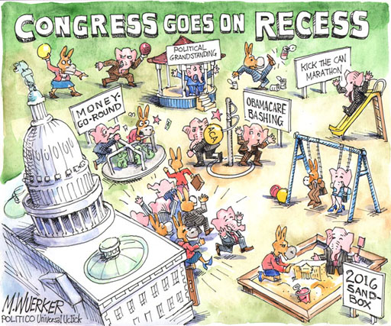
Assignment: For the next nine weeks you are encouraged to create a portfolio of TEN political cartoons that specifically address current events from this summer, June through the beginning of September (Approximately 9 weeks). The cartoons must focus on political and cultural events that have had a domestic or international impact. Your selection of topics within your portfolio must be different.

All cartoons and explanations should be neatly prepared in a digital slide presentation such as Power Point, Google Slides, Prezi, etc.

Grading: Students who have successfully completed the summer assignment will receive up to a 5% boost to their 1st quarter (MP1) grades in both American Civilization English and US/VA History classes.

Requirements:
1. A copy of the cartoon must be attached with typed explanation.
2. Explain the meaning the cartoon in one to two paragraphs.
3. Explain the symbolism, if any, within the cartoon.
4. Provide your reaction to the cartoon and the specific event that is the
focus of the artist.
5. The 10 cartoons must each focus on different topics.
6. Media outlets that provide political cartoons:
theweek.com/cartoons | www.washingtontimes.com/cartoons/
www.usnews.com/cartoons | www.nationalreview.com/photos/category/cartoons/
www.usatoday.com/opinion/cartoons/ | www.washingtonpost.com/syndication/cartoonists/
www.newyorker.com/humor | New York Times
www.wsj.com/news/opinion

7. The project is due at the end of the second week of school.

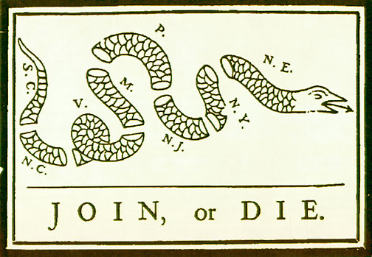

(Identify the significance of this political cartoon.)
ENJOY YOUR SUMMER
cory.mainor@apsva.us / gregory.keish@apsva.us

