AMERICAN CIV. – 2019 SUMMER ASSIGNMENT
Portfolio of Political Cartoons

Name:

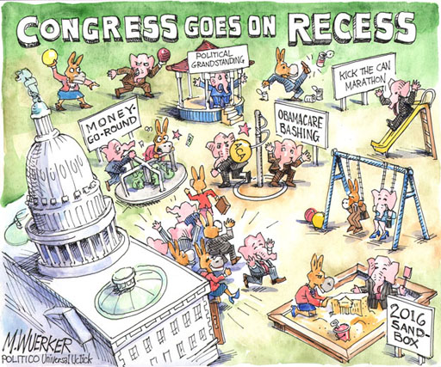
Assignment: For the next nine weeks you are required to create a portfolio of TEN political cartoons that specifically address current events from this summer, June through the beginning of September (Approximately 9 weeks). The cartoons must focus on political and cultural events that have had a domestic or international impact. Your selection of topics within your portfolio must be different.

All cartoons and explanations should be contained in a notebook or folder. Explanations can be hand-written or typed.

Requirements:
1. A copy of the cartoon must be attached with written explanation.
2. Explain the meaning the cartoon in one to two paragraphs.
3. Explain the symbolism, if any, within the cartoon.
4. Provide your reaction to the cartoon and the specific event that is the
focus of the artist.
5. The 10 cartoons must each focus on different topics.
6. Print and online media outlets that provide political cartoons:
Washington Post Fox News / MSNBC The Atlantic
New York Times CNN The Economist
New Yorker TIME
Wall Street Journal Newsweek
Washington Times U.S. News and World Report
7. The project is due at the end of the second week of school.

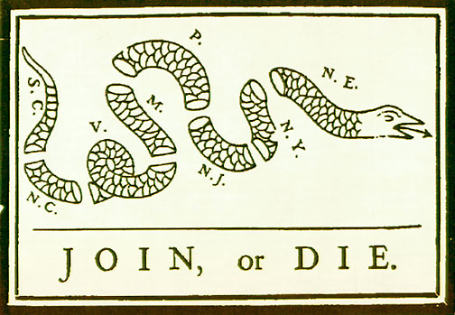

(Identify the significance of this political cartoon.)
ENJOY YOUR SUMMER
cory.mainor@apsva.us / gregory.keish@apsva.us

